The past 50 years in Nutrition: Why the food pyramid of the 70’s had it all wrong…and how we are paying for it.

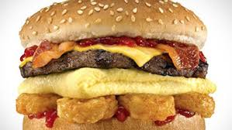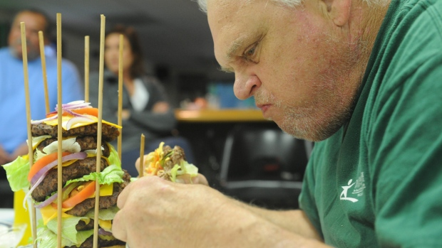
http://www.wcvb.com/image/view/-/20515642/medRes/4/-/maxh/460/maxw/620/-/gts7wgz/-/Gross-Foods---Carls-Jr-Breakfast-Burger-http://www.cbc.ca/gfx/topvideo/2014/elke-burger-challenge.jpgjpg.jpg

#1 What if it’s all been a big fat lie?
http://www.nytimes.com/2002/07/07/magazine/what-if-it-s-all-been-a-big-fat-lie.html?pagewanted=all
- When did Atkins publish his “Diet Revolution” book?
- According to the Atkins diet what has been causing the rise in obesity in America?
- Walter Willett, chairman of the department of nutrition at the Harvard School of Public Health, may be the most visible proponent of testing his “heretic” hypothesis. According to his research, when did the obesity (and diabetes) epidemic being?
- What is endocrinology?
- According to David Ludwig, a researcher at Harvard Medical School who runs the pediatric obesity clinic at Children's Hospital Boston, “Endocrinology 101” requires an understanding of how carbohydrates affect what?
- Why does the author claim that “it's possible to find at least some published research to support virtually any theory”?
- Type 2 diabetes often accompanies obesity. It used to be called adult-onset diabetes and now, for the obvious reason, is not. Why?
- Compare the thrifty gene to the spendthrift gene.
- Why is this theory of weight gain and inability to lose weight and keep it off untestable?
- It is also undeniable, note students of Endocrinology 101, that mankind never evolved to eat a diet high in _______________________
- Until the late 70's, the accepted wisdom was that fat and protein protected against overeating by making you______________
- It was Ancel Keys, paradoxically, who introduced the low-fat-is-good-health dogma in the 50's with his theory that dietary fat does what?

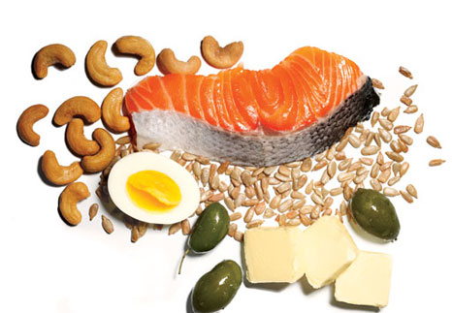
http://femalefitnesstrickytips.com/wp-content/uploads/2013/01/which-are-bad-fats-281x300.jpg
http://www.womenshealthmag.com/sites/womenshealthmag.com/files/images/1205-fat.jpg

#2 The truth about fats: the good, the bad, and the in-between

http://www.health.harvard.edu/staying-healthy/the-truth-about-fats-bad-and-good
- Why did a switch in low fat foods not make the public healthier?
- Why are fats necessary in our diet?
- What are the “bad” fats and “good” fats?
- With regard to structure, what makes one fat different from another?
- What is hydrogenation and what is it’s the purpose ?
- What is the safe level of consumption for trans fats?
- Healthy fats are generally ______at room temperature
- What are the differenes between monounsaturated and polyunsaturaded fats?
- Olive oil is an example of a __________unsaturated fat.
- Fats that your body can not make but are required for normal bodily functions are called what?
- What are the two main types of polyunsaturated fats?(2 points)

#3 The Great Grain Conundrum
http://toxipedia.org/download/attachments/17044484/Report%20%2318%20-%20Great%20Grain%20Conundrum.pdf?version=1&modificationDate=1388194221000&api=v2
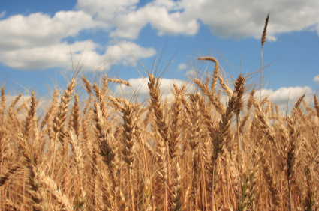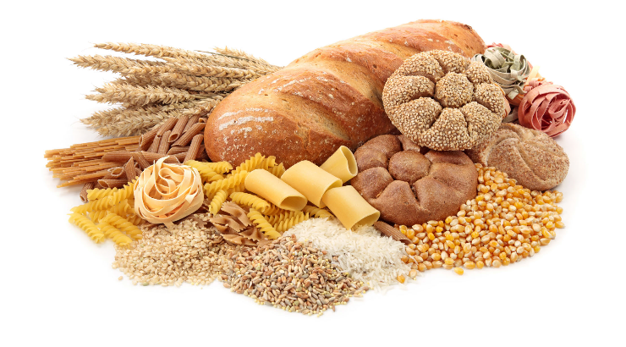https://encrypted-tbn0.gstatic.com/images?q=tbn:ANd9GcSQEp_JdL-a3jL9vnNn0PpcW2qrfxvz5IHe9DZcOb5nqiiyLUFtdA,http://bonfirehealth.com/wp-content/uploads/2011/09/grain.jpg
- According to the author, how has the scientific community changed it’s position on wheat and other grains?
- What are anti-nutrients?
- What foods contain phytic acid and what are the 3 adverse effects of this protein?
- What probiotic produces phytase?
- Which antinutrients can contribute to suppression of thyroid activity?
- Gluten is actually a compound of two storage proteins. What are they?
- According to the article, there are several types of gluten which vary from grain to grain. However, by definition “technically” gluten is a term applied specifically to the prolamin-glutelin combination found in what?
- Which prolamine has been implicated as the main environment factor in causing Celiac disease?
- What is damaged in Celiac disease?
- Symptoms of Gluten sensitivity are similar to celiac disease. What are these symptoms?
- Gluten molecules are resistant to the enzymes that break down proteins. What are these enzymes called?
- According to David (2010) what explains the rise in Celiac disease since the 1960s?
- What causes a “leaky gut”?
- a leaky gut can allow ________ and other toxic compounds to enter in to the blood stream and general circulation.
- gliadin can be similar in structure to other proteins found in tissues of such organs as the _______ or the ___________.
- The most common nutritional deficiencies in gluten intolerance and Celiac disease are:
- (Please Scroll down to section entitled: “Amylopectin A”) The most digestible form of amylopectin is amylopectin-A, found in wheat. Because it is the most digestible, it is the form that most rapidly increases blood sugar. This is why, gram for gram, wheat increases _________________ to a greater degree than, say kidney beans or potato chips. Or in other words, wheat products are no better and are often worse, than even simple carbohydrates such as ____________.
- The higher the blood glucose after consumption of food, the greater the insulin level, the more _________ is deposited.

#4 Leaky gut: what it is and how to heal it
http://health.usnews.com/health-news/blogs/eat-run/2014/03/06/leaky-gut-what-it-is-and-how-to-heal-it
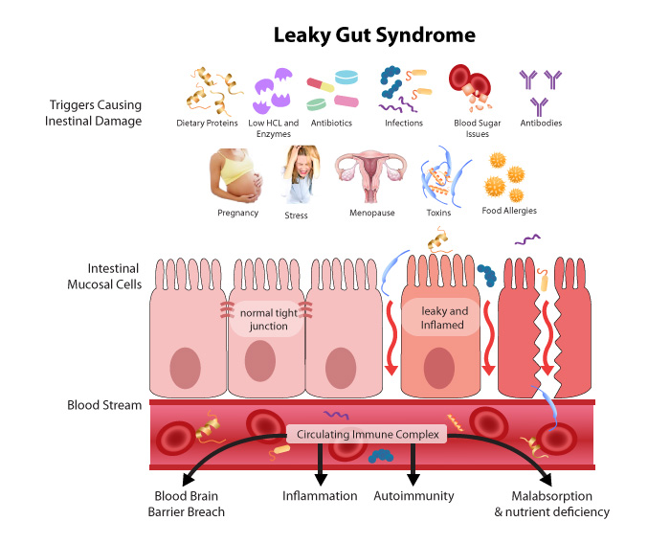

- In order for the vitamins and minerals to be absorbed, the small intestine contains ________________________so the nutrients can be transferred into the bloodstream.
- The problem with leaky gut is it causes the pores in your intestine to ___________.
- How does an increase in pore size in the intestine lead to allergies?
- According to the article, what are two ways to develop a leaky gut?(2 points)
- According to the author, what are three ways to heal a leaky gut?

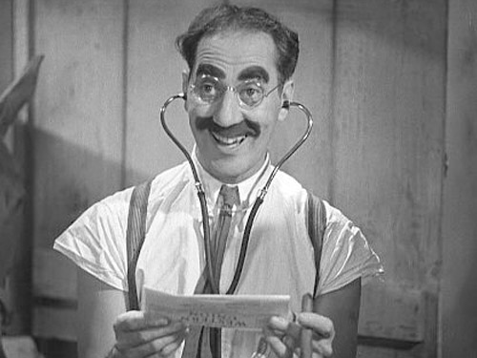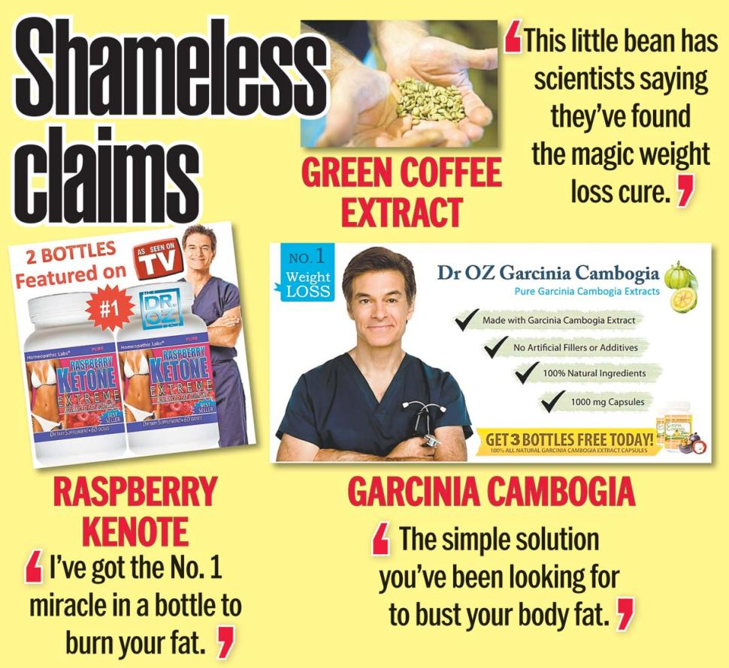
http://12840-presscdn-0-47.pagely.netdna-cdn.com/wp-content/uploads/2014/06/marxundiacarreras.jpg http://maxresultstraining.com/wp-content/uploads/2015/04/dr.-oz-claims.jpg

#5 Quacks or good advice?
http://www.alternet.org/personal-health/four-biggest-quacks-plaguing-america-their-bad-claims-about-science
- Why did the FDA send Dr. Mercola warning letters?
- According to the author, what are three claims against Mercola?
- According to the author, what are three claims against “the health ranger”, Mike Adams?
- According to Dr. David Gorski, Why is the “Food Babe’s” strategy effective?
- Gorski says since companies live and die by public perception, it's far easier to “give a blackmailer like Hari what she wants than to try to do what?
- According to the article, what does Vani Hari claim happens to water when exposed to the word “Hitler”?
- ​Dr. Oz is professor at the Department of Surgery at Columbia University, directs the Cardiovascular Institute and Complementary Medicine Program at New York-Presbyterian Hospital, has authored more than 400 medical research papers and holds several patents. Why is he included in the author’s list of “Quacks”?

